**Q1 answer:**

The code is copied from the .cpp text in Ubuntu:

#include<iostream>

#include<ctime>

#include<limits.h>

using namespace std;

void insertion_sort(int v[], int n)

{

int value;

int i, j;

for (i = 1; i < n; i++)

{

value = v[i];

j = i - 1;

while (j >= 0 && v[ j ] > value)

{

v[j + 1 ] = v[j];

j--;

}

v[j + 1] = value;

}

}

void merge_sort(int v[], int n)

{

int A[50];

int B[50];

int i, j, k;

int value;

for (i = 1; i <= (n / 2); i++)

{

A[i] = v[i - 1];

B[i] = v[i + n / 2 - 1];

}

if ((n % 2) == 0)

{

B[i] = INT_MAX;

A[i] = INT_MAX;

}

else

{

B[i] = v[n - 1];

B[i + 1] = INT_MAX;

A[i] = INT_MAX;

}

for (i = 2; i <= (n / 2); i++)

{

value = A[i];

j = i - 1;

while (j >= 0 && A[j] > value)

{

A[j + 1] = A[j];

j--;

}

A[j + 1] = value;

}

for (i = 2; i <= ((n+1) / 2); i++)

{

value = B[i];

j = i - 1;

while (j >= 0 && B[j] > value)

{

B[j + 1] = B[j];

j--;

}

B[j + 1] = value;

}

i = 1;

j = 1;

for (k= 0; k< n; k++)

{

if (A[i] <= B[j])

{

v[k] = A[i];

i++;

}

else

{

v[k] = B[j];

j++;

}

}

}

void print_vector(int v[], int n)

{

int i;

cout << "Vector:";

for (i = 0; i < n; i++)

cout << " " << v[i];

cout << endl;

}

int main()

{

int v[22];

int u[22];

int i;

double n1, n2;

clock_t start, end, start1, end1;

for (i = 0; i < 22; i++)

{

v[i] = 22 - i;

u[i] = 22 - i;

}

print_vector(v, 22);

start = clock();

insertion_sort(v, 22);

end = clock();

n1 = (double)(end - start) / (double)(CLOCKS_PER_SEC)*(double)(1000.000000);

cout << "The running time of the 22 size input in insertion sort is "<<n1<<" ms"<< endl;

print_vector(v, 22);

print_vector(u, 22);

start1=clock();

merge_sort(u, 22);

end1=clock();

n2 = (double)(end1 - start1) / (double)(CLOCKS_PER_SEC)*(double)(1000.000000);

cout << "The running time of the 22 size input in merge sort is "<<n2<<" ms"<< endl;

print_vector(u, 22);

return 0;

}

Through the code and continuing to change some values, I can get when n=22, the merge sort will beat the insertion sort. As you can see

In the picture below, the size of input indicates the number of n in an array. I can change the value of n in the main fuction.When n>22, the running time of insertion sort will be more than that of merge sort.

At first, I would do the experiment in Windows10. After some trials, I found that the base of CPU time is ‘ms’ which is not precise enough. So at last I use ubuntu to show it.

As you see, when n=22, the running time of insertion seat is 0.002 ms. The running time of merge sort is 0.001 ms. All inputs are set in the worst-case.

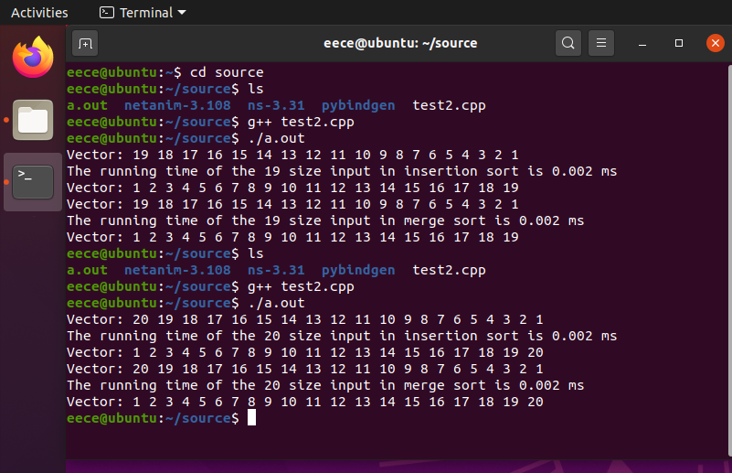

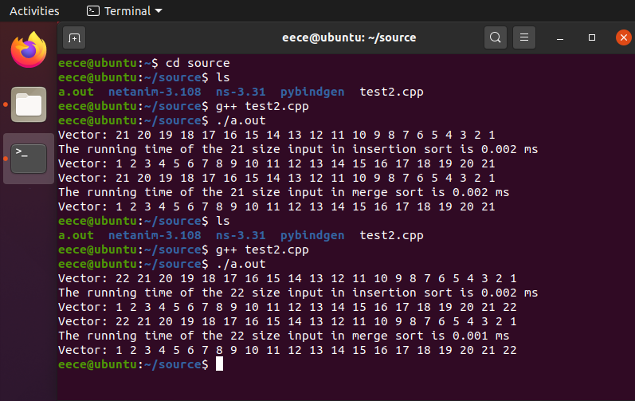

**Q2 answer:**

Initial array: 10,5,7,9,8,3

Iteration of insertion sort:

5,10,7,9,8,3

5,7,10,9,8,3

5,7,9,10,8,3

5,7,8,9,10,3

3,5,7,8,9,10

The last array is the result of insertion sort.

Initial array:10,5,7,9,8,3

So, the iteration of quick sort is:

10,5,7,9,8,3

3,5,7,9,8,10

3,5,7,9,8,10

3,5,7,9,8,10

3,5,7,8,9,10

**Q3 answer:**

$n+3∈Ω\left(n\right)$ is true.

$n+3∈O\left(n^{2}\right)$ is true.

$n+3∈Θ\left(n^{2}\right)$ is false, $n+3∈O\left(n^{2}\right)$

$2^{n+1}∈O\left(n+1\right)$ is false, $2^{n+1}∈Ω\left(n+1\right)$

$2^{n+1}∈Θ\left(2^{n}\right)$ is true.

**Q4 answer:**

$T\left(n\right)=8T\left(\frac{n}{2}\right)+n$, for some $ε>0$, $n=O\left(n^{3-ε}\right)$, so $T\left(n\right)=θ\left(n^{3}\right)$.

$T\left(n\right)=8T\left(\frac{n}{2}\right)+n^{2}$, for some $ε>0$, $n^{2}=O\left(n^{3-ε}\right)$, so $T\left(n\right)=θ\left(n^{3}\right)$.

$T\left(n\right)=8T\left(\frac{n}{2}\right)+n^{3}$, if $k=0$, $n^{3}=θ\left(n^{3}\right)$, so $T\left(n\right)=θ\left(n^{3}\log{n}\right)$.

$T\left(n\right)=8T\left(\frac{n}{2}\right)+n^{4}$, for some $ε>0$, $n^{4}=Ω\left(n^{3+ε}\right)$, and for some $ε^{l}>0$, $\frac{n^{4}}{2}≤\left(1-ε^{l}\right)n^{4}$, so $T\left(n\right)=θ\left(n^{4}\right)$

**Q5 answer:**

The recursion tree is as the picture below:

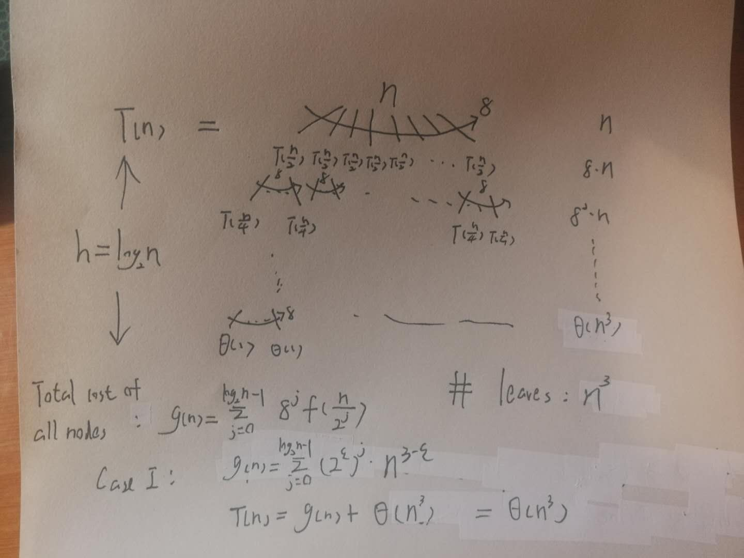

**Prove:**

Guess $T\left(n\right)=θ\left(n^{3}\right)$;

Assume $T\left(n\right)≤c_{1}n^{3}-c_{2}n^{2}$ for all $n>n_{0}$ and $T\left(n\right)≥c_{3}n^{3}+c_{4}n^{2}$ for all $n>n_{0}$;

For the former $T\left(n\right)=8T\left(\frac{n}{2}\right)+n≤8*c_{1}*{\left(\frac{n}{2}\right)}^{3}-8*c_{2}*{\left(\frac{n}{2}\right)}^{2}+n$

$=c_{1}n^{3}-c_{2}n^{2}-n\left(c_{2}n-1\right)$ and if $c_{2}=1, n_{0}=1, n\left(c_{2}n-1\right)>0$, so

$T\left(n\right)≤c_{1}n^{3}-c_{2}n^{2}$, $T\left(n\right)=O\left(n^{3}\right)$

For the latter $T\left(n\right)=8T\left(\frac{n}{2}\right)+n≥8*c_{3}*{\left(\frac{n}{2}\right)}^{3}+8*c_{4}*{\left(\frac{n}{2}\right)}^{2}+n$

$=c_{3}n^{3}+c_{4}n^{2}+n\left(c_{4}n+1\right)$ and if $c_{4}=1, n_{0}=1, n\left(c_{4}n+1\right)>0$, so

$T\left(n\right)≥c_{3}n^{3}+c_{4}n^{2}$, $T\left(n\right)=Ω\left(n^{3}\right)$

For base case, $T\left(1\right)≤c_{1}-c_{2}$ and $T\left(1\right)≥c_{3}+c_{4}$ for that $c_{1}$ is much larger than $c_{2}$ and $c_{3}, c_{4}$ are very small.

In summary, $T\left(n\right)=θ\left(n^{3}\right)$